

**EMPLOYEE LEAVE MANAGEMENT SYSTEM**

**FUNDAMENTAL OF SOFTWARE DEVELOPMENT**

**CT010-3-1**

**Name of lecturer:**

**Tanveer Khaleel Shaikh**

# INTRODUCTION

The system we build is an employee’s Leave Management system which is used in organisations that deals with education. The system is about creating and managing leave policies, Leave balancing, Frequently asked questions (FAQs) about the leave policies and the list of public and company holidays. This system is used by the HR, Academic leader and lecturer and in order to use the system, they must sign in. The HR of this system is responsible for the creation of new Academic Leader’s profile, providing login is and password. The HR can also modify, view profile of lecturer and employee status, Upload leaves and Holidays and update FAQs about the University’s leave policies. The Academic leader in this system can view lecturer’s leave application and either approve or reject it and can also view the holidays and Leave Policies of the university. The lecturer in this system has access to applying for Leave, checking the Leave application status and viewing all holidays and the Leave policy of the university.

## PSEUDOCODE

Begin

Input ELMS to user’s search engine

If (correctly spelt and found)

Display “Welcome to ELMS website”

Else

Display “server not found”

Enter username & password

If (username or password is True)

Display “select option to login (HR, Academic Leader, Lecturer)”

Else

Display” username or password is Incorrect”

Enter username & password again

Accept username & password when True

(user does not have an account)

Display “Create a new account”

Enter name

Enter password

Enter date of birth

Enter Gender

Enter Email address

Enter number

Enter location

Enter type of login: HR. Academic lecturer, Lecturer

Then agree to the term and conditions of the management

“Proceed to sign up to create new account”

Else if (user forgets password)

Please tell user to click ‘forgotten password’

Enter Email address

If (email address exists)

Send password to email

Display “Password has been sent to your email”

Else

Display “Email does not exist”

If (user select HR)

Display “HR login page”

1.Create New Employee

2.Modify lecturer

3.View lecturer

4.Search lecturer

5.View Employee Leave Status

6.Update Yearly Leaves

7.Upload Public and University Holidays

8.Update and upload FAQs about University’s Leave Policies

If (HR, choose 1)

Allow HR to provide new login id

Name

Password

Login type:(lecturer or Academic Leader)

Username

Password

Number

Email

Display “New Lecturer or Academic Leader created”

Else if (HR chooses 2)

Allow HR to make changes

If lecturer/Academic leader wants to change personal information

HR can modify

Display “changes has been made”

Else if (HR chooses 3)

Allow HR to view Lecturer profile

Else if (HR chooses 4)

Allow HR to search lecturer profile

Enter username of lecturer

Display “lecturer profile”

Else if (HR chooses 5)

Allow HR to upload public and University holidays

If (e.g. 21 Jan 2018 is a holiday)

Display “No work on this day”

Else if (HR chooses 6)

Display “FAQs and Uni Leave Polices”

Allow HR to update and upload

Allow user to logout

End IF

User logins (Academic Leader)

Input Username and Password

If (username & password is true)

Display login

else

Display “username or password is Invalid”

If (user cannot login)

Allow user to proceed to Forgotten Password

Enter email

Display “password has been sent to your email”

Else IF (valid) login:

Display “Academic Leader login page”

1. View lecturer leave application
2. Approve/reject leave
3. View public and University holidays

If (Academic leader chooses 1)

Enter lecturer’s name

Display “lecturer application”

Else if (chooses 2) and Academic leader approve leave

Lecturer can go for leave

Else

Lecturer cannot go for leave

Display “Academic leader has rejected your leave “

Else if (chooses 3)

Allow Academic leader to view all holidays

If (it’s a public holiday)

No work on that date

Else

There is work on that day

Logout

End If

User logins (Lecturer)

Input Username and Password

If (username & password is incorrect)

Allow user to login

else

Display “username or password is Invalid”

Else IF (valid) login:

Display “Lecturer login page”

1. Apply for leave
2. Leave Application Status
3. Public and University Holidays leave Policies

If (lecturer chooses 1)

Display “leave application is pending”

Allow user to apply for leave

Else if (lecturer chooses 2)

Display “status of lecturer leave application”

Allow lecturer to view if approve/rejected

Else If (lecturer chooses 3)

Display “public and University holidays”

End IF

End

## SAMPLE OUTPUTS

## Figure 1 (INVALID PASSWORD)

A screenshot of a social media post

Description generated with very high confidence

This program is designed to detect if username is correct while the password is incorrect, in such scenario it displays, incorrect password, as shown above meaning the username is correct while the password is incorrect. And it automatically gives you option to enter the username and password again.

## 2 (INVALID USERNAME)

A screenshot of a social media post

Description generated with very high confidence

This program is designed to detect if password is correct while the username is incorrect, in such scenario it displays, incorrect username, as shown above meaning the username is incorrect while the password is correct. And it automatically gives you option to enter the username and password again.

## Figure 3 (INVALID USERNAME AND PASSWPORD)

A screenshot of a social media post

Description generated with very high confidence

This program is designed to automatically detect if both the username and the password entered are incorrect, it displays a message of incorrect username and password as shown above, and it gives you option to also enter the username and password again.

## Figure 4 (CORRECT PASSWORD AND USERNAME)

A screenshot of a social media post

Description generated with very high confidence

After the login, the system will show the main menu of the program. It has eight functions, which are REGISTRATION, UPDATE, DELETE, VIEW REPORT OF LECTURER, UPLOAD YEARLY LEAVES, UPLOAD PUBLIC AND UNIVERSITIES HOLIDAYS, FAQs and UNIVERSITIES POLICIES AND EXIT. This functions allows the user to choose the number of the option from the main menu. As shown above.

## Figure 5 (REGISTRATION)

A screenshot of a cell phone

Description generated with very high confidence

After a successful login, the first option given is the registration, the user which is the HR has a choice to register any of the above option in this system. If one of the option is choose above then an Academic leader or Lecturer is registered.

## Figure 6 (REGISTIRING AN ACADEMIC LEADER)

A screenshot of a social media post

Description generated with very high confidence

After a successful login, if the option of registration is chosen, firstly the program will check which option is chose after that registration can be done and a confirmation message will be print as shown above after a successful registration. Looking above we can see a successful registration for an academic leader saved in the file and this login ID can be used to login for an academic leader account. It will take the user back to the main menu automatically.

## Figure 7 (REGISTIRING A LECTURER)

A screenshot of a social media post

Description generated with very high confidence

After a successful login, if the option of registration is chosen, firstly the program will check which option is chose after that registration can be done. Looking above we can see a successful registration for a lecturer saved in the file and this login ID can be used to login for an academic leader account. It will take the user back to the main menu automatically.

## Figure 8 (GO BACK)

A screenshot of a social media post

Description generated with very high confidence

Looking at the picture above we can see that the user has a freedom to go back which is added to the registration. The moment the user choses the “go back” option it automatically goes back to the HR option in order to choose another option if the HR wishes to modify, Delete etc….

## Figure 9(INVALID PASSWORD AND NAME FOR UPDATE)

A screenshot of a social media post

Description generated with very high confidence

If the option of update is chosen by the user, firstly the lecturer name and password will be entered, and the system will verify the details if it’s not in the system a message will be displayed as shown above and the user will be automatically taken back to the main menu.

## Figure 10 (VALID PASSWORD AND NAME FOR UPDATE)

A screenshot of a social media post

Description generated with very high confidence

When the user chooses the option of update, the lecturer name and password will be required for authentication, if the login ID is in the system the user will be able to update the contact number and the and a confirmation message of a successful update will be displayed as show above.

## Figure 11 (INVALID LOGIN DETAILS FOR DELETE)

A screenshot of a social media post

Description generated with very high confidence

When the user choses the delete option, firstly the system will require first name and last name of lecturer/Academic leader to delete his details, if the login details are not registered a message of “Details is not in the system” will be displayed as shown above. And the user will automatically be taken back to the main menu.

## Figure 12 (VALID LOGIN DETAILS FOR DELETE)

A screenshot of a social media post

Description generated with very high confidence

When the user choses the delete option, the lecturer first name and second name will be required for authentication, if login details exist, the deletion process will occur and a message of completed delete will be displayed as show in the screenshot above. And the user will automatically be taken back to the main menu.

## Figure 13(INVALID LOGIN DETAILS FOR REPORT)

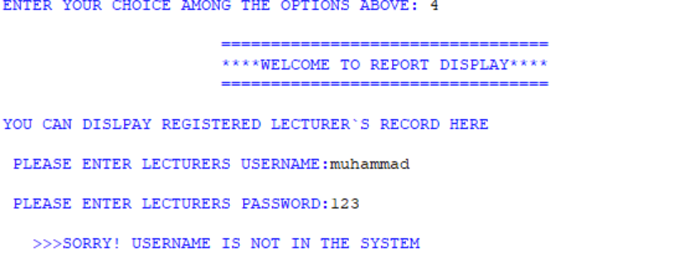

When the user choses the fourth option for display report, the system will require a username and password of the lecturer to display his details, if the login details is not in the system a message will be displayed as shown above of username is not in the system and the program will automatically go back to the main menu.

## Figure 14 (VALID LOGIN DETAILS FOR REPORT DISPLAY)

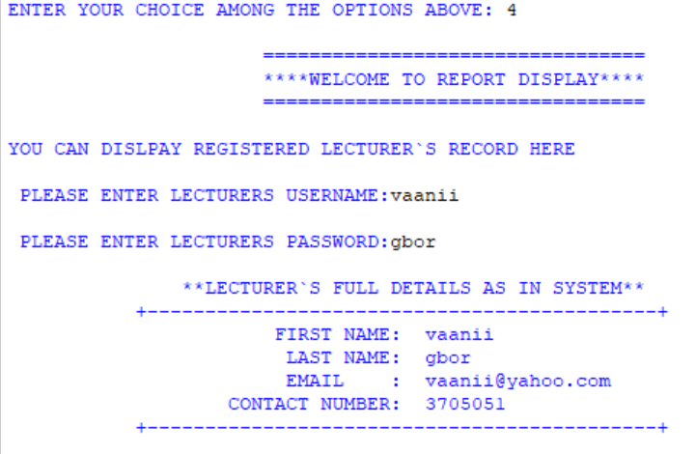

## Figure 15(UPLOAD YEARLY LEAVES)

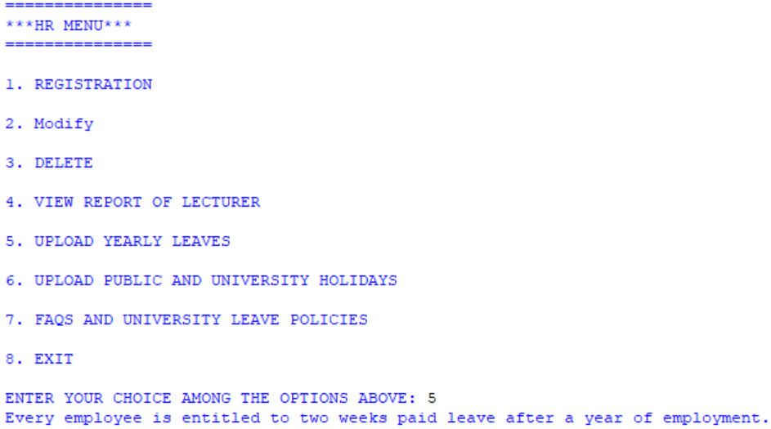

When the user chooses the option upload yearly leaves, it is immediately displayed in front of the screen, this is telling the number of leaves required for a lecturer to take.

## Figure 16 (UPLOAD PUBLIC AND UNIVERSITY HOLIDAYS)

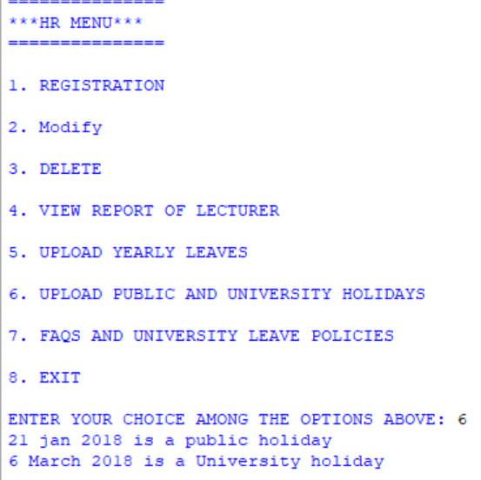

When the user chooses option 6 (public and university holidays) it is displayed in front of the user, it is also displayed under the academic leader and lecturer application.

## Figure 17(FAQs and University leave policies)

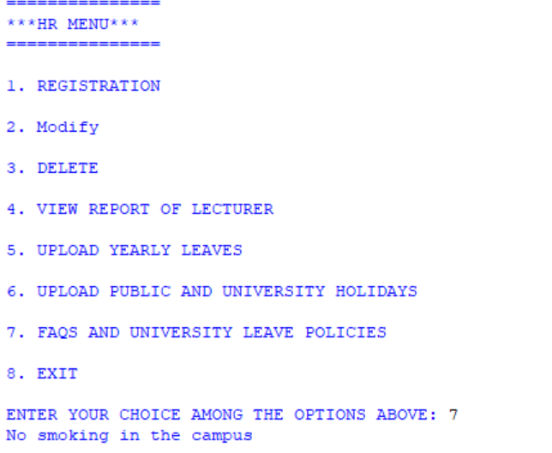

When the user choses option 7 we can see above that the University policy is displayed which is abided by the academic leader and lecturer to strictly follow.

## Figure 18(EXIT)

A screenshot of a social media post

Description generated with very high confidence

When the user choses the last option which is of exit, the program is designed to take few seconds and then display a goodbye message shown above, then it finally exits.

## Figure 19 (INVALID CHOICE FROM MAIN MENU)

A screenshot of a cell phone

Description generated with very high confidence

There are only 4 options in the main menu of the program, this program is designed to automatically detect any choice that is made outside the five options provided, an invalid choice message is displayed as shown above. And it automatically displays the main menu again while reminding the user to make choice between 1 – 4 as shown above. This program also works successfully for other users as well.

## Figure 20(INVALID USERNAME AND PASSWORD FOR ACADEMIC LEADER)

A screenshot of a social media post

Description generated with very high confidence

This program is designed to automatically detect if both the username and the password entered are incorrect, it displays a message of incorrect username and password as shown above, and it gives you option to also enter the username and password again.

## Figure 21(VALID USERNAME AND PASSWORD FOR ACADEMIC LEADER)

A screenshot of a social media post

Description generated with very high confidence

After a successful login, the system will show the main menu of the program. It has five functions, which are VIEW LECTURER LEAVE APPLICATION STATUS, APPROVE LECTURER LEAVE, REJECT LECTURER LEAVE, PUBLIC AND UNIVERSITIES HOLIDAYS, FAQs and UNIVERSITIES POLICIES AND EXIT. These functions allow the user to choose the number of the option from the main menu. As shown above.

## Figure 22(VIEW LECTURER LEAVE APPLICATION)

A screenshot of a social media post

Description generated with very high confidence

When the user chooses the option 1, the lecturer name and password will be required for authentication, if the login ID is in the system the user application is checked if lecturer has applied for leave and the and a confirmation message of lecturer application is displayed as we can see above.

## Figure 23(ACADEMIC LEADER APPROVE LECTURER LEAVE)

A screenshot of a social media post

Description generated with very high confidence

When the user chooses the option 2, the lecturer name and password will be required for authentication, if the login ID is in the system the user will be able to approve the lecturer application either to go for leave or not. Looking at the screenshot above we can see that the academic leader has approved a lecturer’s application and a confirmation message of a successful approval will be displayed as show above.

## Figure 24(ACADEMIC LEADER REJECT LEAVE)

A screenshot of a social media post

Description generated with very high confidence

When the user chooses the option 3, the lecturer name and password will be required for authentication, if the login ID is in the system the user will be able to reject the lecturer application either to go for leave or not. Looking at the screenshot above we can see that the academic leader has rejected a lecturer’s application and a confirmation message of a successful rejection will be displayed as show above.

## Figure 25(INVALID USERNAME AND PASSWORD FOR LECTURER)

A screenshot of a social media post

Description generated with very high confidence

This program is designed to automatically detect if both the username and the password entered are incorrect, it displays a message of incorrect username and password as shown above, and it gives you option to also enter the username and password again.

## Figure 26(VALID USERNAME AND PASSWORD FOR LECTURER)

A screenshot of a social media post

Description generated with very high confidence

After a successful login, the system will show the main menu of the program. It has five functions, which are APPLY FOR LEAVE, PUBLIC AND UNIVERSITIES HOLIDAYS, AND Go Back. These functions allow the user to choose the number of the option from the main menu. As shown above.

## Figure 27(LECTURER APPLY FOR LEAVE)

A screenshot of a social media post

Description generated with very high confidence

When the user chooses the option 3, the lecturer name and password will be required for authentication, if the login ID is in the system the user will be able to apply for leave which is then send to the Academic leader as processing for approve or reject. Looking at the screenshot above we can see that the lecturer has applied for leave and a confirmation message of a successful application will be displayed as show above.

## Figure 28(LECTURER CHECK LEAVE STATUS)

A screenshot of a social media post

Description generated with very high confidence

When the user chooses the option 2, the lecturer name and password will be required for authentication, if the login ID is in the system the user application is checked if applied leave is still processing, approved or rejected and a confirmation message of lecturer status is displayed as we can see above lecturer application is still “Processing”.

# SOURCE CODE OF PYTHON

## VARIABLE

A screenshot of a cell phone

Description generated with very high confidence

This variable is assigned for the user to choose among the option listed the ‘int’ allows the user to choose an option using numbers.

## IF CONDITION



This condition is used for the user to choose either of the option then it will display.

## ELSE CONDITION



This condition is used to give the user an option to choose either option. Looking at the screenshot above we can see that the user enters a username and password if it is not true it displays this message.

## NESTED IF ELSE CONDITION



This is another condition which tells the user you can choose multiple option as we can see above it tells the user choose option 3 if not option 1.

## WHILE LOOP

**A screenshot of a cell phone

Description generated with high confidence**

The while loop stated above Loops (repeated steps) have iteration variables that change each time through a loop. Often these iteration variables go through a sequence of numbers.

## FOR LOOP

A screenshot of a cell phone

Description generated with very high confidence

The for loop I stated above is to check the range of data in my files and read if true it will take the actual data I want to read and display if true and exits it stops.

## Break

A screenshot of a social media post

Description generated with very high confidence

The break statement ends the current loop and jumps to the statement immediately following the loop as shown above if the user choose option 8 which is exit it logouts out and break it immediately.

## Files

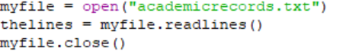

The above picture indicates how to open a file either to read ‘r’ write ‘w’ or add ‘a’ what I did above is to open a file and read data.

## Function

**A screenshot of a social media post

Description generated with very high confidence**

I defined a function using the def reserved word by using the function name, parenthesis and arguments in an expression. The function I called here is academicmenu as soon as an academic leader login the menu should display. What I did in my code is if the login details of an academic leader is true the function is called under it.

## List

**A screenshot of a cell phone

Description generated with very high confidence**

Each element of a sequence is assigned a number - its position or index. The first index is zero, the second index is one, and so forth. Looking at the screenshot above the list stated above is used to list the data in the file.

# TEST PLAN

|  |  |  |
| --- | --- | --- |
| **CODING** | **EXPECTED** | **EXECUTION** |
| Registration | Create new lecturer/Academic leader | correct |
| Modify | Change lecturer new contact | correct |
| View report | Check lecturer profile | correct |
| Yearly leaves | Viewed by HR, Academic leader and lecturer | correct |
| View lecturer leave application | Academic leader can view | correct |
| Approve/reject leave | Lecturer application is being rejected or approved by academic leader | correct |
| Apply for leave | Lecturer can process application | correct |
| Invalid username or password | By HR, Academic leader and Lecturer | correct |
| Valid username or password | By HR, Academic leader and Lecturer | correct |

# ADDITIONAL FEATURES

## TIME.SLEEP

**A screenshot of a cell phone

Description generated with very high confidence**

Looking at the screenshot above I added a functionality to let the program wait for 3 seconds then display. ‘time. Sleep (3)’.

## CLEAR SCREEN

**A screenshot of a social media post

Description generated with very high confidence**

Another additional feature I added to my code is to clear the screen as soon as an incorrect password or username is displayed.

## DELETE

**A screenshot of a cell phone

Description generated with very high confidence**

The delete function I added to my system is to give the HR power to delete any lecturer or Academic leader instead of going to the file to delete.

## GLOBAL DATA

**A screenshot of a cell phone

Description generated with high confidence**

The keyword global is only useful to change or create global variables in a local context, although creating global variables is seldom considered a good solution.

# Conclusion

To sum up the report, this program will be very important to APU to manage the employee leave management system. The program will solve the lecturer’s problem of waiting a long time to apply for leave and waiting for a reply. The program has a very good customized interface that provides several functions in the main menu. It will make it very fast and easy for the staff to let lecturer’s book leave for the whole year by registering the Lecturer details into the system database, and also the system will allow the user to update the lecturer’s details or even delete any lecturer or academic leader easily after or during the leave time. And the system also allows the user to display a report of the registered lecturer. Although the program provides a very secure system which consider **Username** and **Password** to login into the program and access the system functions and database, it is very easy to use and it is able to run on any computer.

# References

Bibliography: Posted and Rouse, M. (2005) *what is python? - Definition from WhatIs.Com*. Available at: http://searchenterpriselinux.techtarget.com/definition/Python (Accessed: 13 May 2016).

begin python, 2016. *begin python.* [Online]   
Available at: http://www.beginpython.com/  
[Accessed 1 5 2016].

code mentor, 2016. *code mentor.* [Online]   
Available at: https://www.codementor.io/python/tutorial  
[Accessed 1 5 2016].

codecademy, 2016. *codecademy.* [Online]   
Available at: codecademy.com/learn/python  
[Accessed 1 5 2016].

divein to python, 2016. *divein to python.* [Online]   
Available at: http://www.diveintopython.net/toc/index.html  
[Accessed 1 5 2016].

docs.python, 2016. *docs.python.* [Online]   
Available at: docs.python.org/3/tutorial  
[Accessed 1 5 2016].

google developers, 2016. *google developers.* [Online]   
Available at: https://developers.google.com/edu/python/?hl=en  
[Accessed 1 5 2016].

learnpython.org, 2016. *learnpython.* [Online]   
Available at: http://www.learnpython.org/  
[Accessed 1 5 2016].

pyschools, 2016. *pyschools.* [Online]   
Available at: http://www.pyschools.com/  
[Accessed 1 5 2016].

python swaroopch, 2016. *python swaroopch.* [Online]   
Available at: http://python.swaroopch.com/  
[Accessed 1 5 2016].

tutorial spoint, 2016. *tutorial spoint.* [Online]   
Available at: http://www.tutorialspoint.com/python/  
[Accessed 1 5 2016].